Lesson 3: How does speed affect whether or not you will avoid a collision?

Previous Lesson | We analyzed videos of two drivers encountering a sudden obstacle, one who is not distracted, and one who is distracted.
This Lesson  Investigation  1 day   | 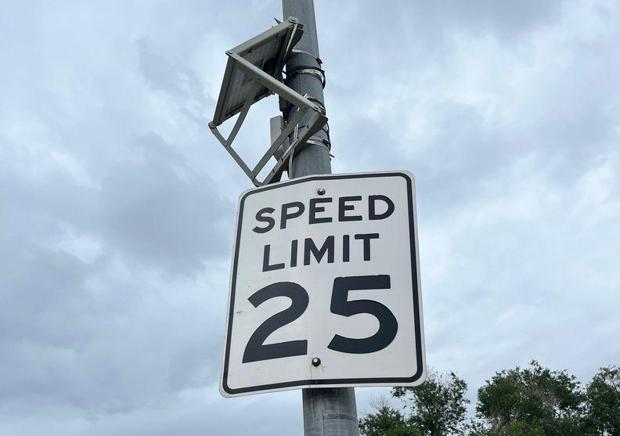 | We use mathematical models to generate data about how speed affects stopping distance based on average reaction times for distracted vs. non-distracted drivers. We use what we have figured out from video data and mathematical modeling to identify design features that can decrease stopping distances to prevent collisions in the event of a sudden obstacle. The speed we are going definitely makes a difference in whether or not we are going to hit the car. But by braking in time, we can bring that speed down quite a bit. We are wondering how speed at the moment of a collision affects the outcome of the collision, assuming it cannot be avoided.
Next Lesson | We will analyze data collected from speed and force sensors for two carts colliding. We will develop a series of mathematical representations to describe quantitative patterns we notice between the masses and the changes in velocity of the two carts.

BUILDING TOWARD NGSS  HS-ETS1-3, HS-PS2-2, HS-PS2-3, HS-PS2-1   | What students will do  3.A Use a mathematical model (distance = speed * time) to generate data about how speed affects stopping distance based on average reaction times for distracted vs. not-distracted drivers. (SEP: 5.2; CCC: 3.5; DCI: ETS1.A.2).  3.B Use student-generated evidence from video data and mathematical modeling to make a claim about the problem of distracted driving identify design solutions that could have the effect of decreasing stopping distances to prevent a collision in the event of a sudden obstacle, and identify a range of constraints associated with each solution. (SEP: 6.5; CCC: 2.3; DCI: ETS1.A.2, ETS1.B.1)  What students will figure out  - We can plot the speed with which a vehicle travels over time to learn more about how it is moving, including how its speed is changing.  - If you are going faster before the collision, your reaction time will not change, but your reaction distance will, because distance = speed * time.  - Some engineering solutions that can affect reaction distance include speed limits, heads-up displays, and phones that turn off notifications while driving.

Lesson 3 • Learning Plan Snapshot
Part | Duration | Summary | Slide | Materials
1 | 5 min | NAVIGATE BY LOOKING BACK AT EXIT TICKETS  Use the exit tickets to motivate a look at speed. | A
2 | 17 min | SPEED V. TIME GRAPHING  Eliciting help from students, draw a graph of speed versus time at the front of the room for both drivers. Students make predictions in their notebooks about how a higher speed would affect the graphs we made. | C | chart paper, chart markers (three colors)
3 | 15 min | INVESTIGATING SPEED VS. REACTION DISTANCE  Use Calculating Reaction Distances to investigate the impact of speed on stopping distance and stopping time. | D | Calculating Reaction Distances, ruler
4 | 5 min | SPEED LIMITS DISCUSSION  Debrief the investigation briefly and consider speed limits as a design solution. Introduce the Engineering Design Tracker and fill in just the first row (the other rows will be Home Learning). | E-F | Calculating Reaction Distances
5 | 3 min | NAVIGATE: HOME LEARNING AND EXIT TICKET  Assign Home Learning and administer an exit ticket to navigate into the next lesson. | G-H

End of day 1

Lesson 3 • Materials List
 | per student | per group | per class
Lesson materials | - science notebook  - Calculating Reaction Distances | - ruler | - chart paper  - chart markers (three colors)

Materials preparation (45 minutes)

Review teacher guide, slides, and teacher references or keys (if applicable).

Make copies of handouts and ensure sufficient copies of student references, readings, and procedures are available.

Put three-hole-punches in all the images and handouts so they can be added to students’ notebooks.

In this class students will add to their engineering progress trackers for the first time. Make sure they have a section in their binders ready to put these materials, where they can return over the course of the unit.

Lesson 3 • Where We Are Going and NOT Going

Where We Are Going

Lessons 2 and 3 of this unit are the only lessons in the course that will focus on kinematics. This lesson is focused on some of the basic kinematic conventions and high school level computational thinking that students will need in future lessons in order to figure out how force, momentum and time are related in later lessons. Students will consider how the speed of a vehicle affects the possibility of getting into a collision. In Lessons 4-5, students will begin to apply their ideas about speed, distance, and time to think about the forces in a collision. Kinematics are not emphasized in the NGSS, which is why much of the physics in this lesson are not well aligned to high school Physical Science DCIs. Instead, the major standards-aligned ideas in this lesson are concerned with engineering, and identifying a major challenge with ramifications in communities, an important element of the disciplinary core idea ETS1.A.

This lesson builds on the previous one to coherently build ideas related to the following disciplinary core ideas:
- ETS1.A.1: Defining and Delimiting Engineering Problems. Criteria and constraints also include satisfying any requirements set by society, such as taking issues of risk mitigation into account, and they should be quantified to the extent possible and stated in such a way that one can tell if a given design meets them. (HS-ETS1-1, secondary to HS-PS2-3)
- ETS1.A.2: Defining and Delimiting Engineering Problems. Humanity faces major global challenges today, such as the need for supplies of clean water and food or for energy sources that minimize pollution, which can be addressed through engineering. These global challenges also may have manifestations in local communities. (HS-ETS1-1)

In the last lesson, students identified a major challenge - that distracted driving is dangerous. In this lesson, they learn about a set of design solutions aimed at preventing distracted driving, and consider the constraints on these solutions set by society. Students will consider how the speed of a vehicle affects the possibility of getting into a collision using many of the same algebraic techniques. Students quantify criteria and constraints in the chemistry course, and in unit P.1 (Electricity).

Students will co-develop a definition for the following vocabulary: reaction distance. Be prepared for students to add this phrase to their personal glossaries. Do not ask students to define or keep track of any words until after your class has developed a shared understanding of their meaning.

Where We Are NOT Going

Students will not consider the forces in a collision in this lesson, and will only be thinking about time, distance, and speed. Students will not be using vectors in this lesson, and will be thinking about speed, rather than velocity until Lesson 4. In this lesson, students “invent” speed vs. time graphs in order to understand how initial speed can affect the possibility of a collision. Avoid presenting speed vs. time graphs in a decontextualized way, or as “something we use in physics.” Instead, use student questions to motivate looking at how speed changes over time before a possible vehicle collision, so that it becomes clear why these representations are useful.

LEARNING PLAN for LESSON 3
1 · NAVIGATE BY LOOKING BACK AT EXIT TICKETS | 5 min
MATERIALS: None
Use the exit tickets to motivate a look at speed. Say, Many of you mentioned in your exit tickets that we need to know how fast they were going because this will affect how quickly a driver can slow down. Alternatively, before class you can choose a student who talked about speed in their exit ticket and ask them to share their response now.

Then ask, Who else thinks that the speed that the driver is going before the obstacle appears will make a difference? Ask students for a show of hands.

Present slide A. Use the prompt on the slide (below) to get students thinking about how speed will affect both distance and time.

Suggested prompt | Sample student response
How would the speed that the driver is going affect the position and time of the car? | We think it will take longer (time) to slow down if they are going faster. This should also tell us how far they will travel in the time it takes them to slow down (distance).

Motivate a speed versus time plot. Present slide B. Say, Let’s take a closer look at the speed of the car in the video. We calculated this speed using the slope of the position graph. What could we do to keep track of how this speed changes over time?

Look for students to suggest a plot. If they do, ask, What could a plot of speed over time tell us about distracted driving? Accept all ideas. If they do not suggest a plot, say, Could we do the same thing we did for position, but with speed? What could that tell us?

2 · SPEED V. TIME GRAPHING | 17 min
MATERIALS: science notebook, chart paper, chart markers (three colors)
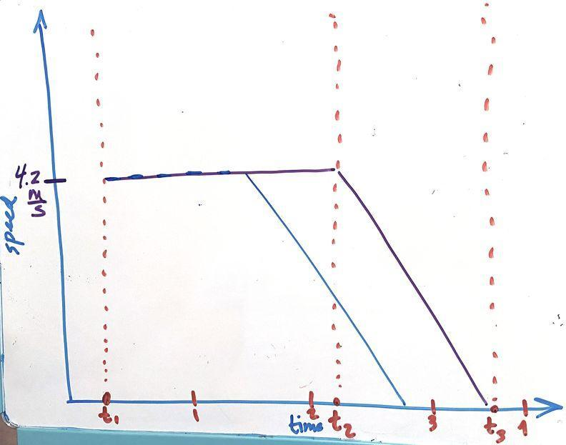
Eliciting help from students, draw a graph of speed versus time at the front of the room. Present slide C. Have a fresh piece of chart paper ready for graphing. Ask students to come up and mark the important timepoints from the video on the bottom, and draw dotted lines up from these points. Then ask students to work in small groups to sketch out speed versus time graphs in their notebooks. Give students 10 minutes to sketch their ideas in groups.

Then bring the class back together and ask, What speed was the car going at between t1 and t2? Did this speed change? Have a student come up to the board to show what their group drew by drawing the line.

Ask, What speed was the car going between t2 and t3? Look for ideas about how the speed was changing. Say, We have some ideas about how the speed is changing, but we all agree that it was going this speed at t2, when the brake lights went on (point to where the line you drew intersects with the t2 dashed line), and had changed to zero by the time we get to t3, which was when the car stopped. Have another student come up and draw a line to connect these points. If students are thinking that the speed might change in a variable way (and they draw something non-linear), ask them to voice their reasoning, but do not shut them down. You can use multiple colors to illustrate different ideas.

Repeat for the distracted driver. Ask, What about for our distracted driver? Repeat this process for the distracted driver in another color. Give students time to make changes to the graphs they made in their notebooks if necessary.

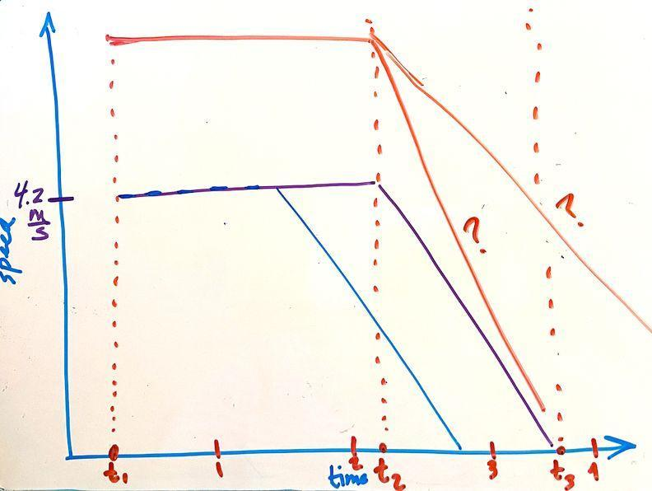
Say, So let’s see what this can tell us about how speed matters. What would happen if this initial speed had been higher? Would the reaction time change? Sketch a straight line above the first line between time 1 and time 2. Accept all ideas here, but make sure to highlight that we aren’t sure. Some students may say that no, the reaction time would not change. Some students may suggest that field of vision changes when you are speeding, or some other mechanism by which initial speed might affect reaction time. Say, It sounds like we aren’t sure about this, but we can’t think of anything that would affect reaction time in a big way, so I think we can assume the same reaction times, even if you are speeding.

Ask, So what would this line look like assuming the reaction time is not affected by initial speed? Point at the space to the right of the line you just drew.

Look for students to say that either the car would take way longer to stop if we mimic the braking lines from before, or they would have to slow down way faster (a much steeper line) between t2 and t3) for both distracted and non-distracted drivers. Accept all ideas right now. Then ask, Does it matter if the driver is distracted? Again, accept all ideas.

Sketch predictions. Give students a minute to sketch their predictions, and a minute to share their ideas with their groups, or with a partner. Then ask for a volunteer to share their ideas. Ask students if they drew something similar or different, and elicit a couple of ideas. Then once there is some consensus, sketch these predictions at the front of the room in another color. Add question marks to show that we aren’t sure.

3 · INVESTIGATING SPEED VS. REACTION DISTANCE | 15 min
MATERIALS: Calculating Reaction Distances, ruler
  Investigate speed vs. reaction distance in pairs. Present slide D. Say, We had some ideas about how our initial speed, the speed we are going before an obstacle appears, might affect our probability of collision. Let’s investigate this further and find out exactly how much of a difference initial speed makes. Pass out Calculating Reaction Distances. Break students into pairs or groups of three to complete the handout.  The handout provides students with the information that the average reaction time is .75 seconds, and assumes that a distracted driver will have a reaction time twice that long (1.5 seconds). This is based on the information from the article we read after L1. Point this out to students. Then move around the classroom and support students as they do the math and the graphing and see that reaction distance increases with speed, and distracted driving doubles that.✱  ASSESSMENT OPPORTUNITY What to look/listen for in the moment: Move around the classroom while students are working. You can also collect students’ handouts at the end of class to give more focused feedback. - Look for students to have correctly applied the equation most of the time, and/or flagging solutions that don’t make sense. (SEP: 5.2) - Look for somewhat straight lines in the graphs, as in the example below. (SEP: 5.2) 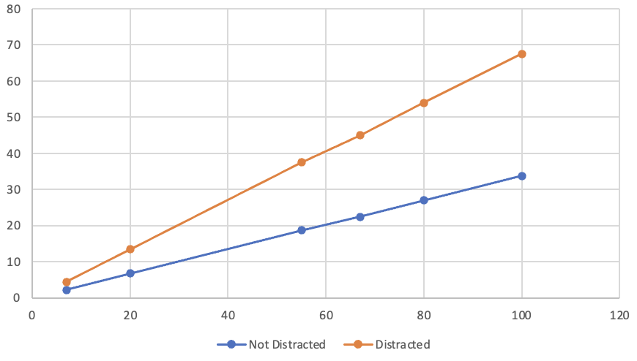 - Look for students to describe how in both scenarios, reaction distance goes up with speed, and thus increase the probability of a collision in the event of an obstacle. (CCC: 3.5; DCI: ETS1.A.2) - Look for students to describe how in the distracted driver scenario, the reaction distance goes up faster with speed, making it even more likely that there will be a collision in the event of an obstacle. (CCC: 3.5; DCI: ETS1.A.2) What to do: Flag incorrect solutions and graphing errors, but focus feedback on the last two questions. Ask students who are having trouble making connections to first point to patterns they see in the graph, using a highlighter to mark where these patterns are happening. Then ask students to “caption” the graph, explaining what might be happening to produce the patterns they identified. This is known as the I² (Identify and Interpret) strategy for scaffolding the analysis of data displays. Building Toward 3.A Use a mathematical model (distance = speed * time) to generate data about how speed affects stopping distance based on average reaction times for distracted vs. not-distracted drivers. (SEP: 5.2; CCC: 3.5; DCI: ETS1.A.2). | ✱ ATTENDING TO EQUITY  Universal Design for Learning: Students can use a calculator to help them do these calculations. Allowing alternatives for use of tools such as a calculator can remove barriers for students in expressing their understanding by keeping the focus on the learning goal. Use of such tools can help provide a match between a student’s abilities and the demands of the task. You might also consider allowing students to use a digital graphing tool such as a graphing calculator, or a spreadsheet software to create their graphs.

4 · SPEED LIMITS DISCUSSION | 5 min
MATERIALS: Calculating Reaction Distances
Debrief the investigation briefly. Present slide E.

Suggested prompt | Sample student response
What did the data say about the impact of speed on reaction distance given a fixed reaction time? | Higher speeds mean longer reaction times, for both non-distracted and distracted drivers.
What evidence can you point to in your graphs to support this claim? | As the speed goes up on the x-axis, the reaction distances went up too, for both lines. It looks linear.
Was this the same for both distracted and not-distracted drivers? | Yes. But when a driver is distracted their reaction distance will be twice as long as it would have been, because their reaction time is twice as long.
What evidence can you point to in your graphs to support this claim? | As the speed goes up for the distracted driver, the reaction distance got even bigger, because everything was doubled. The slope of the distracted line is higher.

Present slide F. Say, Wow speed clearly makes a difference. What can we do to limit people’s speeds? Look for students to suggest that we could impose speed limits.

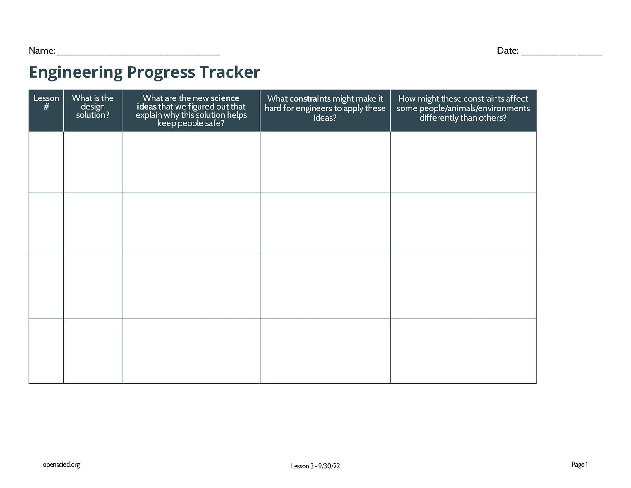
Introduce the Engineering Design Tracker. Say, Let’s keep track of this idea. Pass out the Engineering Progress Tracker and lead a quick discussion to help the class fill in just the first row, as in the example below. Then tell students that they will fill in the rest of the tracker as Home Learning. The rows that students will do as Home Learning are indicated in grey in the example below.

Lesson # | What is the design solution? | What are the new science ideas that we figured out that explain why this solution helps keep people safe? | What constraints might make it hard for engineers to apply these ideas? | How might these constraints affect some people/animals/environments differently than others?
2 | Speed limits | Driving faster means that your reaction distance will be longer. Speed limits prevent people from driving too fast. | People want to go places faster so they don’t like speed limits. Also sometimes people don’t follow the speed limit, so even if you set it people might not follow it. | It is much easier for wealthier people to pay speeding tickets, so a speed limit might not matter as much for them. Also some people might live in places with different speed limits that can affect their commute time.
2 | Heads up displays | Distracted driving means that you have a longer reaction time and less time to slow down to a stop and avoid a collision. Heads up displays let you keep your eye on the road and be less distracted. | It’s expensive and can only be put in new cars, you can’t add them to old cars. | These are only available on expensive new cars, so a lot of people won’t be able to afford them.
2 | No notifications while driving | Distracted driving means that you have a longer reaction time and less time to slow down to a stop and avoid a collision. | You can include this on a phone, but people have to opt-in. | Some people don’t opt-in, and some people don’t know about the feature.

ASSESSMENT OPPORTUNITY | What to look/listen for in the moment:  Collect the Engineering Design Tracker at the start of the next class. Examples of what these might look like in the tracker are in the example below. The rows that students will do as Home Learning are indicated in grey. Look for students to:  - Complete at least one additional design solution row addressing the problem of distracted driving. Ideally students will identify two or three. (DCI: ETS1.A.2)  - Connect each new design solution to a claim that we made during the lesson (or claims) based on evidence about change over time, such as speed, reaction time, reaction distance. (SEP: 6.5; CCC: 2.3)  - Highlight at least one reasonable constraint for each new design solution. (ETS1.B.1)  - Respectfully consider how the constraint might affect some people/animals/environments differently than others.  What to do:  - Provide written feedback to help students set expectations for what the Engineering Design Tracker entries should look like.  - In this feedback, encourage students to expand on their ideas by asking questions like Why? and How?  - Push students to think beyond the driver and passengers of the car. What about pedestrians? Wildlife? Who else might be affected?  Building Toward 3.B Use student-generated evidence from video data and mathematical modeling to make a claim about the problem of distracted driving identify design solutions that could have the effect of decreasing stopping distances to prevent a collision in the event of a sudden obstacle, and identify a range of constraints associated with each solution. (SEP: 6.5; CCC: 2.3; DCI: ETS1.A.2, ETS1.B.1)

5 · NAVIGATE: HOME LEARNING AND EXIT TICKET | 3 min
MATERIALS: None
Assign home learning. Present slide G. Students will read about several design solutions as Home Learning and add them to their Engineering Design Trackers for home learning.  ALTERNATE ACTIVITY Give them a moment to pre-think about these solutions if there is time. To do this, say, We don’t know if speed limits affect reaction time, but they definitely affect reaction distance. Can you think of any design solutions that could increase the amount of reaction time we have? Solicit 2-3 ideas. Accept all ideas. You may see ideas about cell phones that sense when you are driving and turn off notifications, heads-up displays that help keep your eyes on the road, hands free cell phone solutions, or automatic braking.  Explain to students that they will need to read the Home Learning handout: Engineering Faster Reaction Times. Point out that as part of this assignment, they are expected to ask a family, friend or community member:  - What are the speed limits in different parts of our community?  - Have they changed? How? Why do you think they were changed?  - Should they be changed? Why or why not? If so, how?  Navigation and Exit Ticket. Ask students to respond to the prompt on slide H as an exit ticket: How do you think the speed of your vehicle at the moment of a collision might affect the outcome of the collision? | ✱ ATTENDING TO EQUITY  Universal Design for Learning: This home learning is used to broaden students’ thinking to everyday phenomena and leverage these science experiences they have outside of school to augment the learning that happens in the classroom. Framing students’ families and communities as legitimate sources of knowledge can serve multiple purposes. It can 1) help students feel like they belong in the science classroom by situating their family/community knowledge as productive for science, 2) engage students’ families in conversations about what is happening in the classroom, and 3) help students make connections between the science classroom and their everyday lives, supporting their engagement.

